WPNSA Information for 3rd & 4th October

- 420’s are allocated Zone 5 of the dinghy park. Please keep boats there as the site is busy with a Moth event and Speed Week.

- We have training rooms 1 and 2 (upstairs) and room 8 (downstairs) allocated.

- Gate code is 2731
Vehicles are only allowed in the dinghy park to drop off dinghies/equipment, all vehicles must then be parked in the car park over the road opposite.

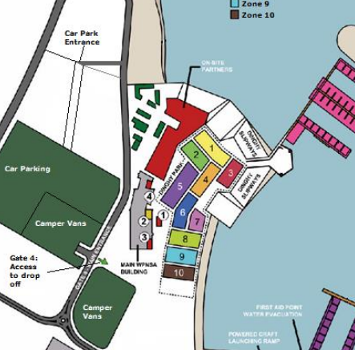

- Road Closures and Traffic news
Hi Everyone,
There will be roadworks along the A354 at the roundabout at the junction of Hamm Beach Road. All vehicles will be prohibited to travel along Portland Beach Road Southbound and Hamm Beach Road Northbound. The alternative route will take all Portland bound traffic along Hamm Beach Road, in front of WPNSA, through Osprey Quay back onto Portland Beach Road.

Due to the anticipated volume of traffic along Hamm Beach Road, we will be operating a one way system on our main site. Please enter the site through Gate 4 and exit through Gate 6 when dropping off or collecting boats. Please do not attempt to exit through Gate 4 whilst Gate 6 is open. Once you have exited through Gate 6 we have been advised that you will be able to turn right at the mini roundabout in order to access our main gravel car park opposite the WPNSA building without having to go all around the one way system.

All vehicles leaving the site and heading for Weymouth will need to join the one way system travelling through Osprey Quay onto Portland Beach Road.

Please be mindful throughout the weekend of the volume of traffic that is likely to travel along Hamm Beach Road and please take extreme care when crossing at all times.

If you have any questions or require any further information please call WPNSA main reception between 9am and 5pm.

Please accept our apologies for any inconvenience caused and we are very grateful for you cooperation.

